**Exercise 7: Packages**

**Scenario 1:** Group all customer-related procedures and functions into a package.

**Table Output:**

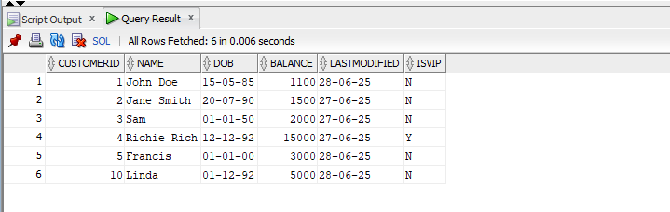

**Script Output:**

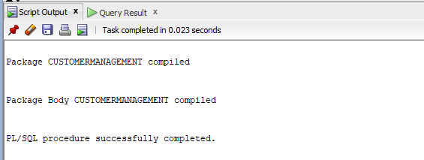

**Table Output 2:**

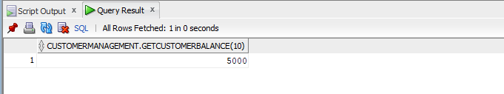

**Scenario 2:** Create a package to manage employee data.

**Table Output:**

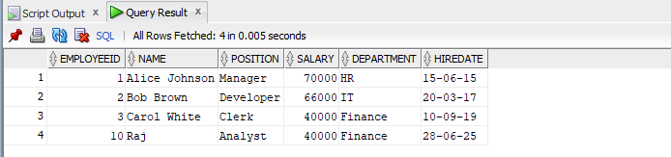

**Script Output:**

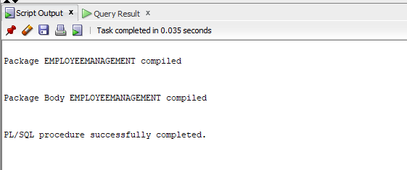

**Table Output 2:**

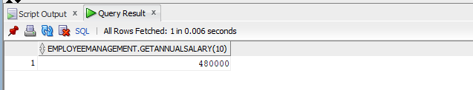

**Scenario 3:** Group all account-related operations into a package.

**Table Output:**

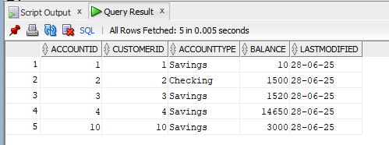

**Script Output:**

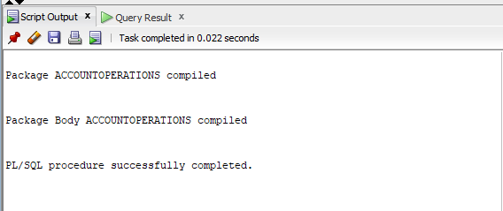

**Table Output 2:**

